**ASSIGNMENT-4**

|  |  |
| --- | --- |
| Date | 23 October 2022 |
| TeamID | PNT2022TMID49499 |
| Name | S udhayanithi |
| MaximumMarks | 2Marks |

# **Question1:**

Write code and connections in work for ultrasonic sensor.Whenever distance is lessthan 100cms send "alert" to ibm cloud and display in device recent events.

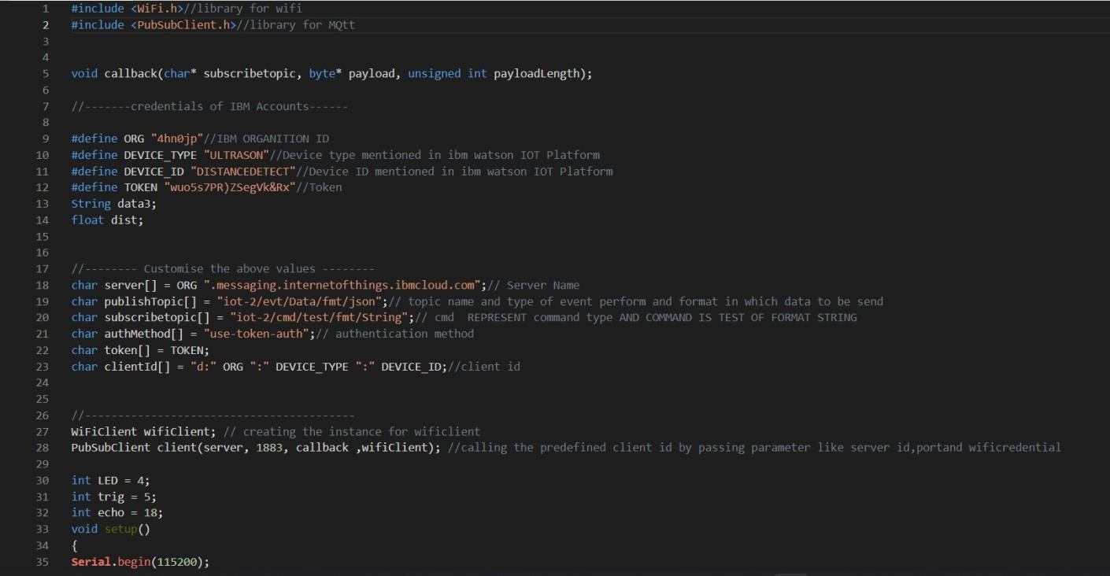**CODE**:

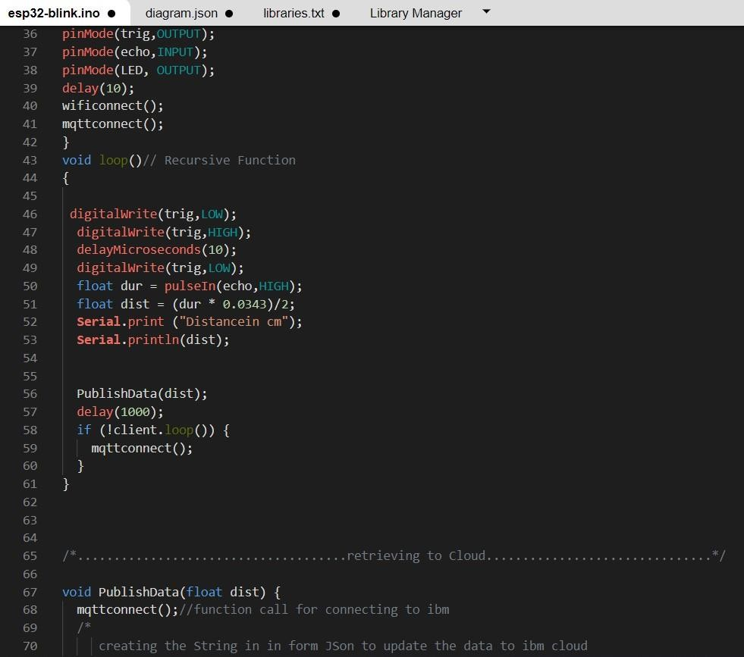

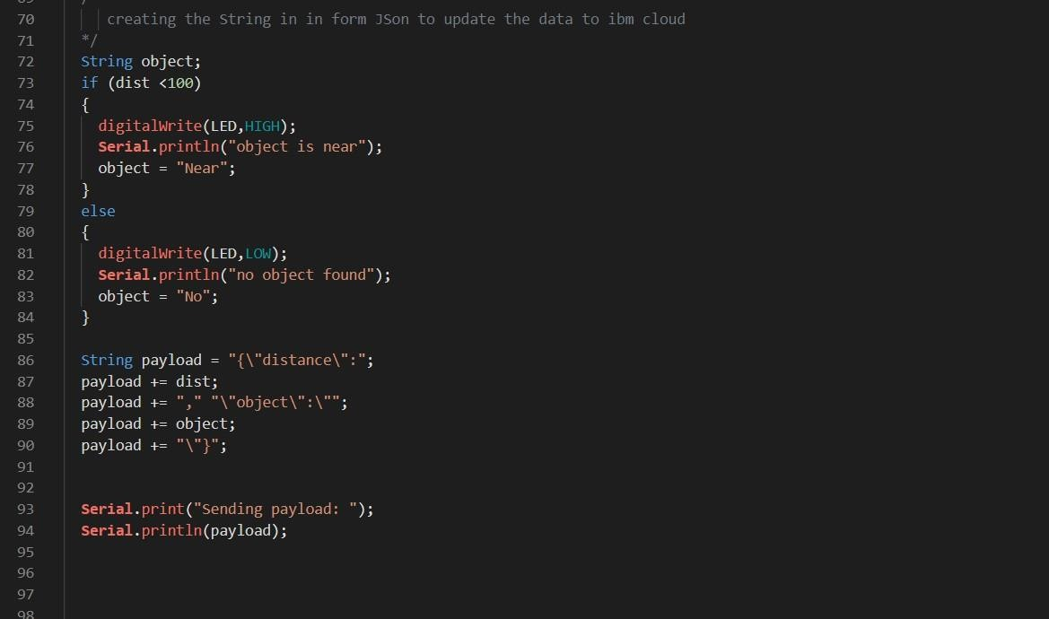

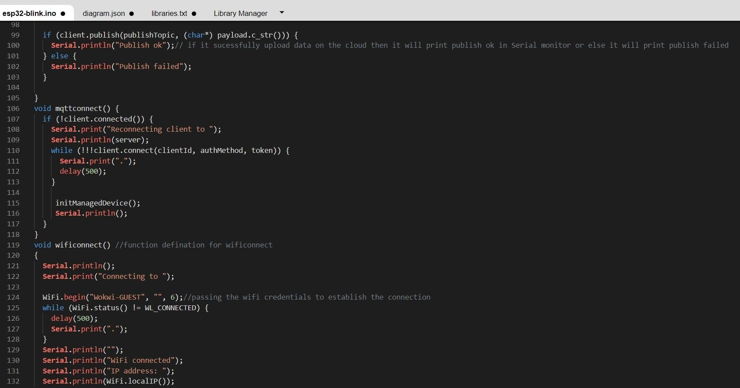

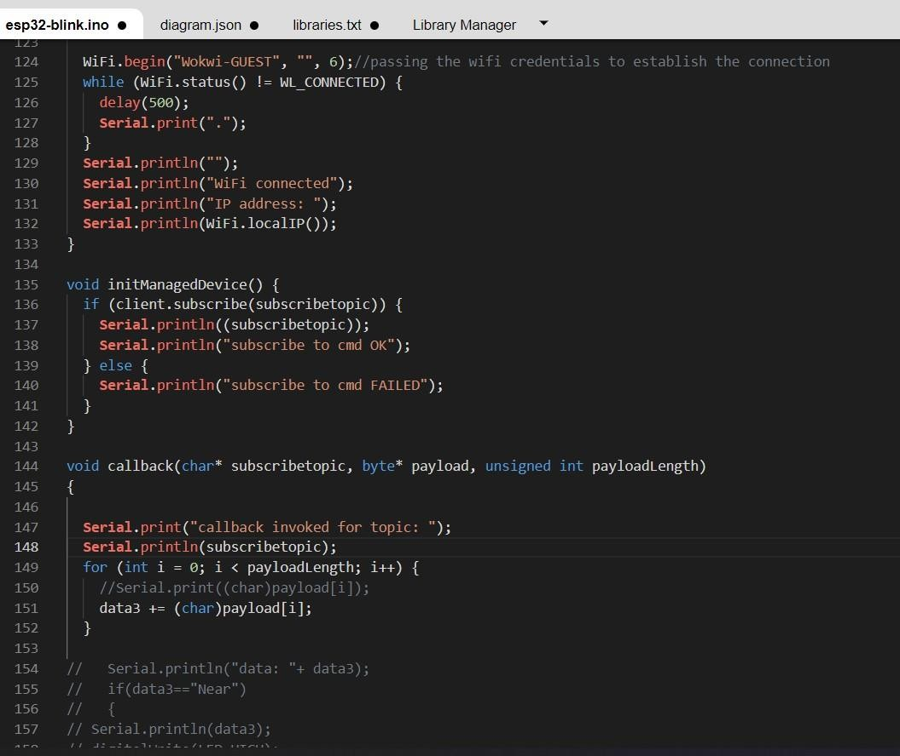

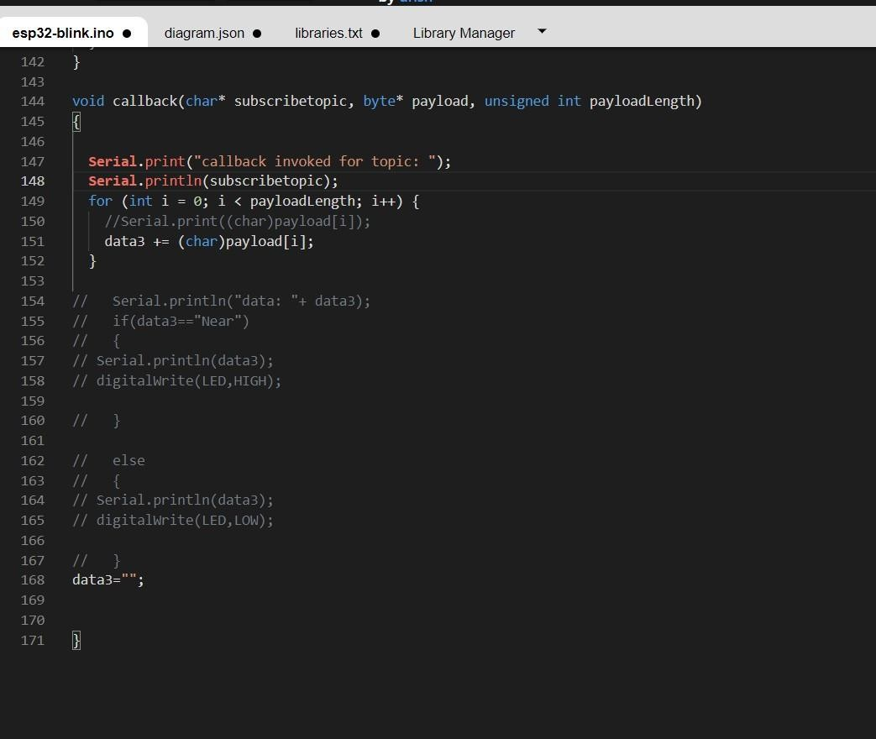

# **OUTPUT**:

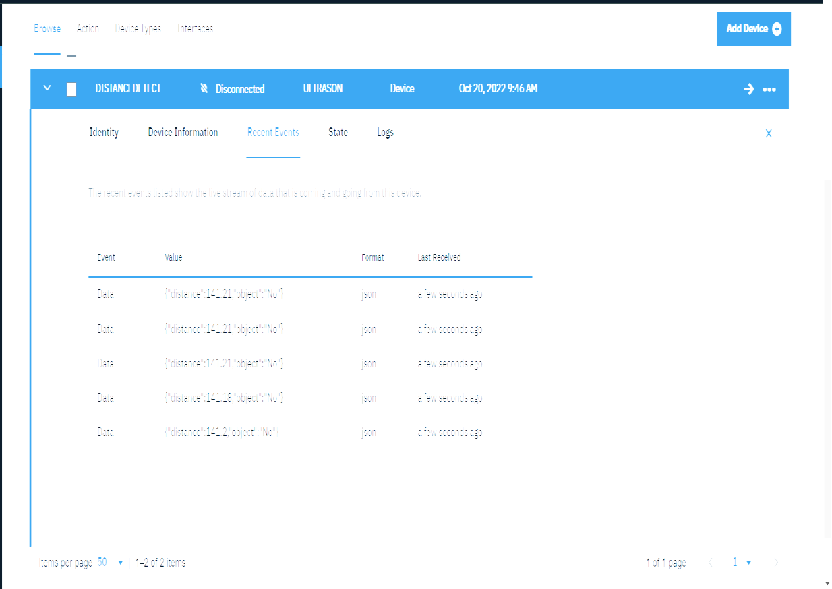Data send to the IBMcloud device when the objectics far

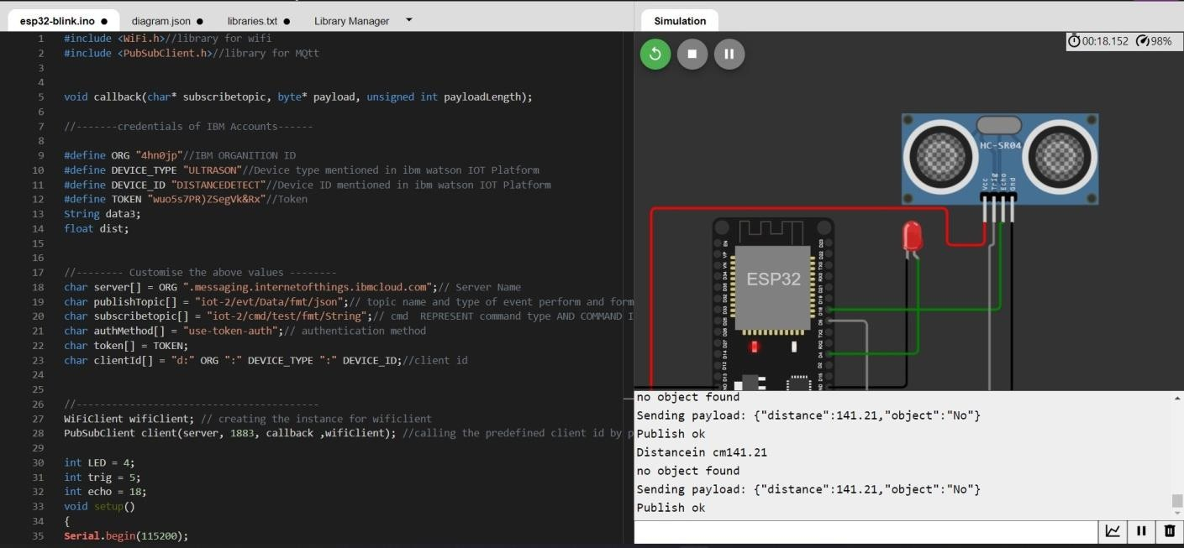

Data sent to the IBMCloud Device when the objectis near

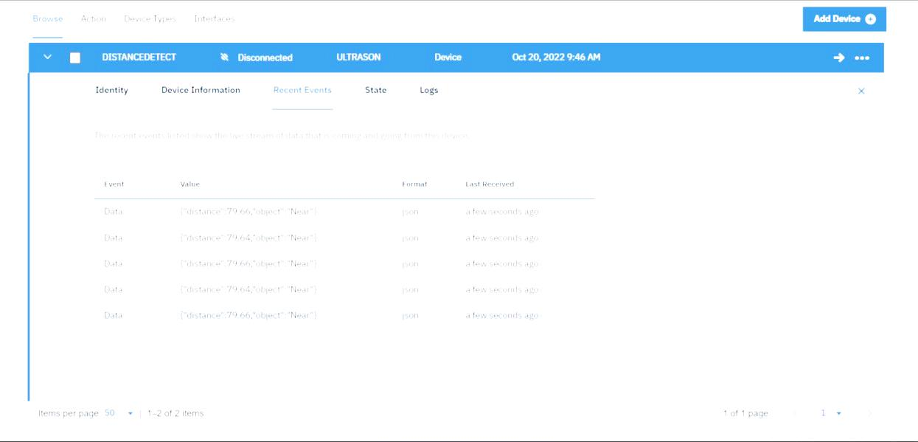

# 

# When objectics near to the ultrasonicsensor